

Complaints & Compliments
Policy & Procedure

Last review completed by | The Board; Policy Task and Finish Group
Date of last review | Sept 2023
Next review due | Sept 2026
Approved by Board | December 2023

Policy statement

Manchester Mind is committed to providing excellent quality, inclusive services. We actively welcome and seek feedback especially from people who use our services as well as our partners, members and the general public. In this way we can learn more about what is working and not working in terms of the services we deliver and the way they are delivered. Sometimes is isn’t easy to hear complaints but we commit to being open and transparent in our acceptance of complaints and the way we deal with them.

Feedback can be provided to us in a variety of ways. It can be done formally through completing a monitoring form after receiving a service or through a complaint when someone is not satisfied with the service they have received. Feedback can also be provided informally by suggesting ways we can change or improve services or through a compliment if a person feels they have received a particularly good service.

All types of feedback are welcomed as it gives us the opportunity to listen to people and improve what we do and the way we do it. In this way we are continuing to adhere to our values of openness, collaboration, belonging and strength.

If a Manchester Mind staff member wishes to make a complaint, please refer to the Grievance Policy.

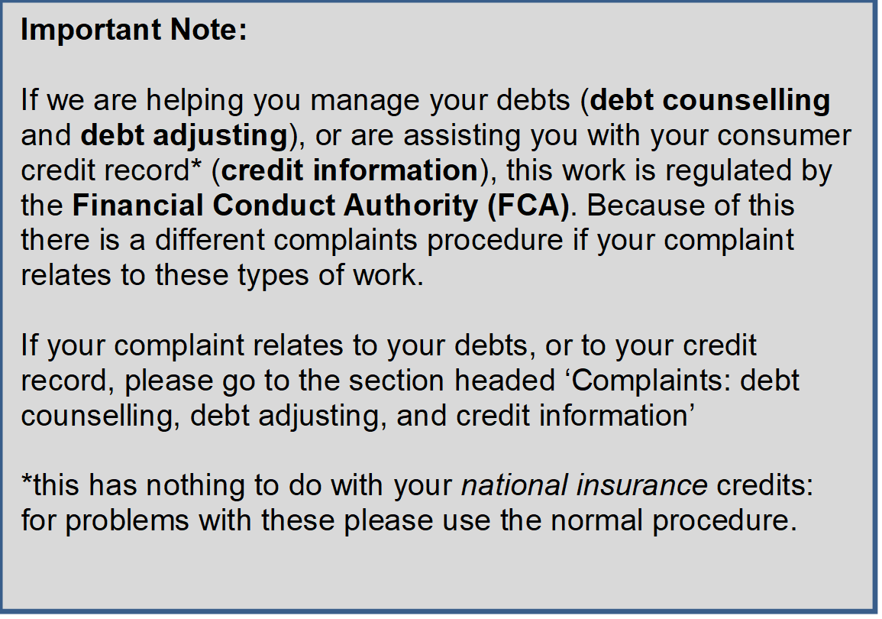

Complaints

We do not look on complaints as unwanted. In fact, they may help us to see where our services could be improved. We welcome suggestions where we have room for improvements or when we have made a mistake.

Any complaints made will be treated in confidence and given serious attention before appropriate action is taken.

If you need help with making a complaint you can ask a member of staff or a friend or family member or even someone you trust from another organisation.

We aim acknowledge receipt of all complaints within five working days and to respond fully to verbal or written complaints within ten working days following acknowledgement of your complaint if possible. If we cannot meet this timeframe, we will give a reason for the delay and a timeframe by which we will get back to you.

Procedure

How to complain

If you are unhappy with any aspect of the service you have received from Manchester Mind, please let us know.

We will always try to resolve the complaint at an early stage and as informally as possible. However, if this is not possible we have complaints process to ensure that your complaint is properly investigated and that you get a response from us.

It is most helpful if you can make your complaint as soon as possible and usually within three months of the date of the event you're complaining about.

Taking your complaint further

Our complaints process is set out in four steps so it is easy to see what to do and what happens if you are unhappy with the response you get from us.

Step 1: Informal Complaint

If you have been unhappy with any aspect of the service you have received from Manchester Mind we hope you have felt able to talk to a member of staff or their line manager.

If you don't feel able or would prefer not to do this you can make your complaint in writing either directly to the member of staff concerned or to their line manager.

We recognise that you may not feel comfortable raising an issue with the person directly and in that case please ask to speak to the person’s line manager or you can write to them. It is not always easy to hear complaints but all our staff will try to be open and acknowledge the issue that you are complaining about. They will do their best to sort out the complaint quickly or they will explain why it cannot be sorted out.

We will try to resolve the problem on the spot if we can. If we can't do this, for example, because information we need is not to hand, then we will take a record of your concern and arrange the best way and time for getting back to you. This will normally be within ten working days or we will make some other arrangement acceptable to you.

Step 2: Formal Complaint

If you have spoken or written to our member of staff or their line manager and feel you are unhappy with the response you received at Step 1 then you can raise a formal complaint.

Write to us with the details of your complaint
You will need to write to the Service Manager or Project Manager of the service you want to make a complaint to. Your written complaint should be sent to info@manchestermind.org and it will be forwarded on to the relevant manager immediately.

You will need to set out the details, explaining what you think went wrong and what you feel would put things right.

If you are not happy about writing a letter or email, you can always ask a member of staff or an independent person to take notes of your complaint, or you can ask to meet with the Service or Project Manager. If notes are taken they should be shared with you, so that we can make sure you agree with what they have recorded and that they provide you with your own copy for reference.

We will investigate your complaint
We will let you know we have received your letter or email by contacting you within five working days.

We will let you know in our letter when you can expect to hear from us again. This should normally be within a further ten working days. This gives us time to fully investigate your complaint. If the matter is complicated and where other people need to be contacted it might take us a little longer. If this is the case we will still let you know what action is being taken and when we expect to provide you with a full response.

Step 3: Appeal following formal complaint

If you are not satisfied with the results of the investigation and the response to your complaint at Step 2 you can appeal. You will need to write to the Chief Executive setting out the details of your appeal, explaining the reasons you disagree with the results of the investigation and what you think is needed to resolve the matter. The contact details for the Chief Executive are below.

The Chief Executive will review your complaint and the details of the investigation along with your reasons for the appeal. The Chief Executive will gather any further evidence needed to ensure your reasons for disagreement with the results of the investigation can be addressed.

The Chief Executive will usually write to you within three weeks to let you know the outcome of your appeal.

Step 4 : Final Appeal

It is possible that even after these stages have been completed you might still be unhappy with the responses you have received about either the decision or any aspect of the way the complaint has been dealt with. In this case you can ask Manchester Mind’s Board of Trustees to consider your complaint.

Manchester Mind is a registered charity and as such is managed by a Board of Trustees. You will need to write to the Chair of Trustees at: trustee@manchestermind.org setting out the details of how the investigation and appeal of your complaint have not been able bring a resolution to the matter.

All materials relating to your complaint and to the investigation will be sent to the Chair of the Board. They will let you know within seven working days that they have received your complaint and tell you when to expect a full response from them.

The Chair of the Board will review your comments with the investigation and appeal documents. They make ask for additional information or evidence. They will provide a full response to your final appeal and this completes the complaints process.

Taking your complaint outside the organisation

We want to take every opportunity to improve our services and to resolve problems. Before taking your complaint outside of Manchester Mind we ask that you first follow steps 1 to 4 of our Complaints Process so all opportunities to resolve your complaint have been exhausted.

If, after the final appeal at step 4, you are not satisfied with the Board's response, you can always seek advice from outside the organisation. It may be possible to seek help from an advice agency or other organisation. Manchester Mind will provide you with details of any services local to your area if we can.

Complaining about the CEO

If your complaint concerns the CEO of Manchester Mind you will need to write directly to the Chair of the Trustee Board at trustee@manchestermind.org. You will need to set out the details of your complaint and what you would like to see changed.

The Chair of Trustees will acknowledge your complaint by writing to you within seven working days and will let you know when you can expect to receive a response.

They will conduct a full investigation and may meet with you to discuss your concerns further. You will be kept up-to-date with how the investigation is progressing and when the outcome is expected. When the investigation has been concluded the Chair or Trustees will write to you setting out the results of the investigation and actions taken or to be taken if any.

Complaining about the Chair of Trustees

If you wish to complain about the Chair of Trustees please write to the Board of Trustees in the first instance and a member of the committee will be nominated to deal with the complaint. The details of who to write to can be provided on request.

You should set out in writing the details of your complaint and what you think is needed to resolve the matter. A member of the trustee committee will contact you to confirm receipt of your letter and let you know when to expect a response. A full investigation will be implemented and a representative of the trustee committee will contact you with the results and details of any actions taken.

If your complaint is serious about the actions of Manchester Mind, you can contact the Charity Commission and for further guidance on the types of complaints the Charity Commission deal with see: https://www.gov.uk/government/publications/complaints-about-charities/complaints-about-charities

Compliments

We welcome any positive feedback or compliments from people who have used our services, or from partners we are working with, about the help and support they have received from us. We are delighted to receive letters or cards saying how beneficial our service has been to you. It is really important for our staff and volunteers to know they have made a difference and helped people and it is also good for us to understand what parts of our service and the way we deliver it has made a difference.

We are pleased to communicate all compliments within the organisation so that recognition can be given.

Suggestions

We also welcome suggestions, especially from people who have used services. You can provide this verbally or in writing and give it to the member of staff who you are most familiar with or pop your note in the suggestion box which is available at each of the buildings we work from. You can also send these in via email to info@manchestermind.org

We use these suggestions to help to continue to improve our services or to develop more areas where we can provide support for our community.

Contact details:

Manchester Mind
Tel: 0161 769 5732
Email: info@manchestermind.org

CEO – Elizabeth Simpson
Tel: 0161 769 5732
Email: elizabeth.simpson@manchestermind.org

Board of Trustees
Email: trustee@manchestermind.org

Manchester Mind provide Advice Services which may involve debt advice –as we need to be compliant with the Financial Services Authority there is a different complaints process for any complaint about our debt advice.

Complaints: debt counselling, debt adjusting, and credit information

You should make your complaint as soon as possible. For more detailed information about time limits see below. We hope that you will complain informally to the person dealing with the matter first to give them a chance to put things right. We hope you will be able to resolve your issue informally and only feel the need to make a formal complaint as a last resort

Formal Complaint

You should put your complaint in writing to the Operations Director setting out the details, explaining what you think went wrong and what you feel would put things right. If you are not happy about writing a letter, you can always ask a member of staff or an independent advocate to take notes of your complaint. You should make sure you agree with what they have recorded and that they provide you with your own copy for reference. This record will be passed promptly to the Operations Director to deal with.

If we can resolve your complaint by close of business on the third business day following the day on which you complained, we will promptly send you a written summary resolution communication, which will:
- refer to the fact that you have made a complaint and inform you that we now considers the complaint to have been resolved;
- tell you that if you subsequently decide that you are dissatisfied with the resolution of the complaint you may be able to refer the complaint to the Financial Ombudsman Service;
- (if your complaint is late) say whether we give consent for the Ombudsman to look at it anyway (see Time limits below);
- Provides the website address of the Financial Ombudsman Service; and
- Refer to the availability of further information on the website of the Financial Ombudsman Service.

If we cannot resolve your complaint by close of business on the third business day following the day on which you complained, we will:
- send you a prompt written acknowledgement providing early reassurance that we have received your complaint and are dealing with it; and
- ensure that you are kept informed thereafter of the progress of the measures being taken to resolve the complaint.

The details of the process are as follows.

We will aim to send you a final response to you by the end of eight weeks after we have received your complaint, which will do one of the following:
- accept your complaint and, where appropriate, offer redress or remedial action; or
- offer redress or remedial action without accepting your complaint; or
- reject your complaint and gives reasons for doing so;

It will also
- enclose a copy of the Financial Ombudsman Service's standard explanatory leaflet;
- provide the website address of the Financial Ombudsman Service;
- inform you that if you remain dissatisfied with the our response, you may now refer your complaint to the Financial Ombudsman Service; and
- (if your complaint is late) say whether we give consent for the Ombudsman to look at it anyway (see Time limits below);

If we cannot respond within eight weeks we will provide you with a written response which will:
- explain why it we are not in a position to make a final response and indicate when we expect to be able to provide one;
- inform you that you may now refer your complaint to the Financial Ombudsman Service;
- (if your complaint is late) say whether we give consent for the Ombudsman to look at it anyway (see Time limits below);
- enclose a copy of the Financial Ombudsman Service standard explanatory leaflet; and
- provide the website address of the Financial Ombudsman Service.

Time Limits

The Ombudsman cannot consider a complaint if you refer it to the Financial Ombudsman Service:
- More than six months after the date on which we sent you our final response, redress determination or summary resolution communication; or
- more than:
  - six years after the event you complained about, or (if later)
  - three years from the date on which you became aware (or ought reasonably to have become aware) that you had cause for complaint;
unless you referred the complaint to us or to the Ombudsman within that period and had a written acknowledgement or some other record of the complaint having been received;

The ombudsman can consider the complaint, even if the time has expired, if:
- there are exceptional circumstances, or
- we give consent to the Ombudsman considering the compliant even though the time limits have expired.



Guidance for Managers and Staff Dealing with Complaints

All complaints made by people using Manchester Mind Services should be taken seriously and dealt with promptly and in confidence. Regardless of the stage within which a complaint is resolved, copies of the complaint together with an anonymised outline of the process and outcomes should be passed onto the Manchester Mind CEO to share learning within the organisation and as evidence for the Mind Quality Mark.

Stage One Informal Complaint

In accordance with the above Policy a person using Manchester Mind services can make a complaint informally to a member of staff. At this stage notes must be kept of the basis of the complaint, any meetings and action taken. Any action taken to resolve the complaint should be confirmed in writing. At this stage the member of staff should be supported by their manager to resolve the complaint informally. Any learning from complaints should be highlighted at team meetings and in supervisions.

Stage Two Formal Complaint - Taking your complaint further

In accordance with the Policy, the complaint will have been made in writing to the relevant Manager. The complaint needs to be acknowledged within five working days. A full investigation must take place and notes kept of all meetings and the decision making process and have due regard to any relevant Manchester Mind policies. A copy of the decision and the reasons for that decision must be made in writing and have regard to the time scale in the Complaints policy. If the complaint is resolved satisfactorily at this stage any learning should be disseminated in relevant team meetings and supervisions. Details of the complaint should be included within Service Quarterly Reports.

Stage Three - Formal Complaint to the CEO

Again if the complaint is passed onto the CEO all written evidence should be provided and notes of reasons for decisions. The CEO may decide to talk to those involved again. Written notes must be kept. Again if the complaint is resolved, any learning must be disseminated through the relevant parts of Manchester Mind and communicated to the Board of Trustees.

Stage Four - Formal Complaint to the Board

If not resolved the Chair of the Board of Trustees will examine the complaint and the way it has been dealt with. All written notes and evidence must be sent to the Chair. The decision making process must be documented and learning from the complaint should be disseminated by the Board with any recommendations that may arise.

Complaints: Regulated Activities

For the main details see the section Complaints: debt counselling, debt adjusting, and credit information above. Additional information and requirements (all references are to the FCA Handbook.)

The Advice Service Manager is responsible for oversight of the firm's compliance with FCA requirements (i.e. DISP 1).

General Principles
Once a complaint has been received by us we must [DISP 1.4]:
(1) investigate the complaint competently, diligently and impartially, obtaining additional information as necessary;
(2) assess fairly, consistently and promptly:
(a) the subject matter of the complaint;
(b) whether the complaint should be upheld;
(c) what remedial action or redress (or both) may be appropriate;
(d) if appropriate, whether it has reasonable grounds to be satisfied
that another respondent may be solely or jointly responsible for
the matter alleged in the complaint;

taking into account all relevant factors;
(3) offer redress or remedial action when it decides this is appropriate;
(4) explain to the complainant promptly and, in a way that is fair, clear
and not misleading, its assessment of the complaint, its decision on it,
and any offer of remedial action or redress; and

(5) comply promptly with any offer of remedial action or redress
accepted by the complainant.
Factors that may be relevant in the assessment of a complaint under include the following:
(1) all the evidence available and the particular circumstances of the
complaint;
(2) similarities with other complaints received by the respondent;
(3) relevant guidance published by the FCA , other relevant regulators,
the Financial Ombudsman Service or former schemes; and
(4) appropriate analysis of decisions by the Financial Ombudsman Service concerning similar complaints received by the respondent (see DISP 1.3.2A G)
We should aim to resolve complaints at the earliest possible opportunity, minimising the number of unresolved complaints which need to be referred to the Financial Ombudsman Service.

Where a complaint against a respondent is referred to the Financial Ombudsman Service, the respondent must cooperate fully with the Financial Ombudsman Service and comply promptly with any settlements or awards made by it.

We must ensure [see DISP 1.3.3] that in handling complaints we identify and remedy any recurring or systemic problems, for example, by:
(1) analysing the causes of individual complaints so as to identify root causes common to types of complaint;
(2) considering whether such root causes may also affect other processes or products, including those not directly complained of; and
(3) correcting, where reasonable to do so, such root causes.

Time Limits for making complaints

The circumstances in which the Ombudsman can consider a late complaint are, in more detail:
‘…
- in the view of the Ombudsman, the failure to comply with the time limits in DISP 2.8.2 R was as a result of exceptional circumstances; or
- the Ombudsman is required to do so by the Ombudsman Transitional Order; or
- the respondent has consented to the Ombudsman considering the complaint where the time limits in DISP 2.8.2 R have expired (but this does not apply to a “relevant complaint” within the meaning of section 404B(3) of the Act).

If a respondent consents to the Ombudsman considering a complaint in accordance with DISP 2.8.2 R (5), the respondent may not withdraw consent.

The six-month time limit is only triggered by a response which is a final response, redress determination or summary resolution communication. The response must tell the complainant about the six-month time limit that the complainant has to refer a complaint to the Financial Ombudsman Service.

An example of exceptional circumstances might be where the complainant has been or is incapacitated.’ [DISP 2.8.2 R]

Speed and quality of response to complaints

‘It is expected that within eight weeks of their receipt, almost all complaints to a respondent will have been substantively addressed by it through a final response or response as described in DISP 1.6.4 R.

When assessing a respondent's response to a complaint, the FCA may have regard to a number of factors, including, the quality of response, as against the complaints resolution rules, as well as the speed with which it was made.’ [DISP 1.6.7-1.6.8]

Summary Resolution Communication (‘three business days’ rules’)

‘The information regarding the Financial Ombudsman Service required to be provided in a summary resolution communication should be set out clearly, comprehensibly, in an easily accessible way and prominently, within the text of those responses.’ [DISP 1.5.5]

The handbook makes it clear that it might sometimes be appropriate to use a different method to communicate this, if this is more suitable to the complainant’s needs.

Key for choosing correct standard letter template (regulated activities only)

These are all found in the following location:

S:\Advice Management\FCA\MM documents

And are prefixed with MA-DISP: the table below (which is also found at this location as DISP-Key) omits these for clarity.

